Stock Management System
Login Frame

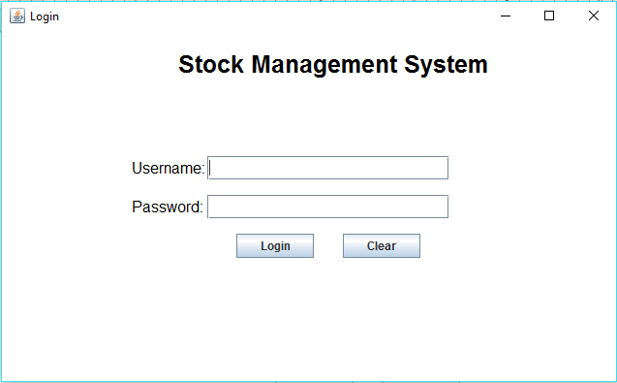
Code:
/*
Author: Hedmilson Guimaraes Jose Domingos
Roll no: 1541029
Christ University
*/

import java.io.*;
import java.awt.*;
import java.awt.event.*;
import javax.swing.*;
import javax.swing.JFrame;
import java.sql.*;
import java.sql.DriverManager;

class store
{
Connection con = null;
public static Connection ConnecrDb()
{
try
{
Class.forName("com.mysql.jdbc.Driver");
Connection con = DriverManager.getConnection(
"jdbc:mysql://localhost/sonoo","root","heddyshost");
return con;
}
catch(Exception e)
{
JOptionPane.showMessageDialog(null,e);
return null;
}
}
}
public class Stock_Management extends WindowAdapter
{
Connection con = null;
ResultSet RS = null;
PreparedStatement PST = null;

Frame f;
Label lb1,lb2,lb3,lb4,lb5;
JLabel background;
JTextField t_username,t_password;
JButton b1,b2;
Image img;
Stock_Management()
{

gui();
con=store.ConnecrDb();
}
public void windowClosing(WindowEvent e)
{
f.dispose();
}
public void gui()
{
f = new Frame("Login");
f.addWindowListener(this);
f.setBackground(Color.WHITE);

Font fn = new Font("TimesNewRoman",Font.PLAIN,16);
Font fn2 = new Font("TimesNewRoman",Font.BOLD,25);
f.setFont(fn);

lb1 = new Label("Stock Management System");
lb1.setForeground(Color.BLACK);
lb1.setFont(fn2);
lb1.setAlignment(Label.CENTER);
lb1.setBounds(180,30,340,70);

lb2 = new Label("Username:");
lb2.setForeground(Color.BLACK);
lb2.setBounds(140,160,80,25);
lb3 = new Label("Password:");
lb3.setForeground(Color.BLACK);
lb3.setBounds(140,200,80,25);

t_username = new JTextField("");
t_username.setBounds(220,160,250,25);
t_password = new JPasswordField();
t_password.setBounds(220,200,250,25);

b1 = new JButton("Login");
b1.setBounds(250,240,80,25);
b2 = new JButton("Clear");
b2.setBounds(360,240,80,25);

b1.addActionListener(new ActionListener()
{
public void actionPerformed(ActionEvent e)
{
try
{
String sql="select * from users where username=? and password=? ";
PST = con.prepareStatement(sql);
PST.setString(1, t_username.getText());
PST.setString(2, t_password.getText());
RS= PST.executeQuery();
if(RS.next())
{
JOptionPane.showMessageDialog(null,"You have successfully logged in");
f.dispose();
mainFrame obj=new mainFrame();
}
else
{
JOptionPane.showMessageDialog(null,"Username or password is incorrect");
}
}
catch(Exception e1)
{
JOptionPane.showMessageDialog(null,e1);
}
}
});

b2.addActionListener(new ActionListener()
{
public void actionPerformed(ActionEvent e2)
{
t_username.setText("");
t_password.setText("");
}
});

f.add(lb1);
f.add(lb2);
f.add(lb3);

f.add(t_username);
f.add(t_password);

f.add(b1);
f.add(b2);

f.setLayout(null);
f.setVisible(true);
f.setSize(650,400);

}
public static void main(String[] args)
{
new Stock_Management();
}
}
Home Frame
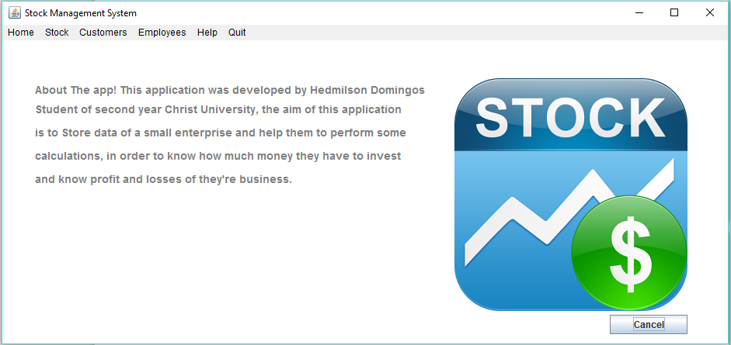
Code:
import java.io.*;
import java.awt.*;
import java.awt.event.*;
import javax.swing.*;
import javax.swing.JFrame;
import java.sql.*;
import java.sql.DriverManager;

public class mainFrame extends WindowAdapter
{
Frame f1;
JButton b1;
JLabel lb_img1;
JTextField t1,t2,t3,t4,t5,t6,t7;

public mainFrame()
{
gui();
}
public void windowClosing(WindowEvent e)
{
f1.dispose();
Stock_Management obj = new Stock_Management();
}
public void gui()
{
f1 = new Frame("Stock Management System");
f1.addWindowListener(this);
f1.setBackground(Color.WHITE);

MenuBar mb = new MenuBar();
Menu menu = new Menu("Home");
Menu menu1 = new Menu("Stock");
Menu menu2 = new Menu("Customers");
Menu submenu_custm = new Menu("Sub Menu");
Menu menu3 = new Menu("Employees");
Menu submenu_emp = new Menu("Sub Menu");
Menu menu4 = new Menu("Help");
Menu menu5 = new Menu("Quit");

// Items for the first menu1
MenuItem i1 = new MenuItem("Register Product");
MenuItem i2 = new MenuItem("Search Product");
MenuItem i3 = new MenuItem("Update Product");
MenuItem i4 = new MenuItem("Delete Product");

// Items for the Customers menu2
MenuItem i6 = new MenuItem("Register");
MenuItem i7 = new MenuItem("Edit");
MenuItem i8 = new MenuItem("View");

// Items for the Employess menu3
MenuItem i9 = new MenuItem("Register");
MenuItem i10 = new MenuItem("Edit");
MenuItem i11 = new MenuItem("View");

//Quit
MenuItem quit = new MenuItem("Close Application");
menu5.add(quit);
quit.addActionListener(new ActionListener()
{
public void actionPerformed(ActionEvent e)
{
try
{
f1.dispose();
}
catch(Exception ex)
{
JOptionPane.showMessageDialog(null,ex);
}
}
});

i1.addActionListener(new ActionListener()
{
public void actionPerformed(ActionEvent e)
{
try
{
f1.dispose();
registerProduct regP = new registerProduct();
}
catch(Exception ex)
{
JOptionPane.showMessageDialog(null,ex);
}
}
});
i2.addActionListener(new ActionListener()
{
public void actionPerformed(ActionEvent e)
{
try
{
f1.dispose();
searchProduct regP = new searchProduct();
}
catch(Exception ex)
{
JOptionPane.showMessageDialog(null,ex);
}
}
});
i3.addActionListener(new ActionListener()
{
public void actionPerformed(ActionEvent e)
{
try
{
f1.dispose();
updateProduct regP = new updateProduct();
}
catch(Exception ex)
{
JOptionPane.showMessageDialog(null,ex);
}
}
});
i4.addActionListener(new ActionListener()
{
public void actionPerformed(ActionEvent e)
{
try
{
f1.dispose();
deleteProduct regP = new deleteProduct();
}
catch(Exception ex)
{
JOptionPane.showMessageDialog(null,ex);
}
}
});
i6.addActionListener(new ActionListener()
{
public void actionPerformed(ActionEvent e)
{
try
{
f1.dispose();
registerCustomer regP = new registerCustomer();
}
catch(Exception ex)
{
JOptionPane.showMessageDialog(null,ex);
}
}
});

Font fn = new Font("Arial",Font.BOLD,14);
JLabel lb1 = new JLabel("About The app! This application was developed by Hedmilson Domingos");
lb1.setForeground(Color.GRAY);
lb1.setFont(fn);
lb1.setBounds(50,100,510,30);
JLabel lb2 = new JLabel("Student of second year Christ University, the aim of this application");
lb2.setForeground(Color.GRAY);
lb2.setFont(fn);
lb2.setBounds(50,130,500,20);
JLabel lb3 = new JLabel("is to Store data of a small enterprise and help them to perform some");
lb3.setForeground(Color.GRAY);
lb3.setFont(fn);
lb3.setBounds(50,160,500,20);
JLabel lb4 = new JLabel("calculations, in order to know how much money they have to invest");
lb4.setForeground(Color.GRAY);
lb4.setFont(fn);
lb4.setBounds(50,190,500,20);
JLabel lb5 = new JLabel("and know profit and losses of they're business.");
lb5.setForeground(Color.GRAY);
lb5.setFont(fn);
lb5.setBounds(50,220,500,20);

JLabel lb_img1 = new JLabel(new ImageIcon("A:/IV_semester/Java_lab/CIA 3/imgs/stock.png"));
//lb_img1.setLayout(null);
lb_img1.setBounds(590,100,300,300);

b1 = new JButton("Cancel");
b1.setBounds(790,405,100,25);
f1.add(b1);
b1.addActionListener(new ActionListener()
{
public void actionPerformed(ActionEvent e)
{
f1.dispose();
Stock_Management obj=new Stock_Management();
}
});

menu1.add(i1);
menu1.add(i2);
menu1.add(i3);
menu1.add(i4);

menu2.add(i6);
menu2.add(i7);
menu2.add(i8);

menu3.add(i9);
menu3.add(i10);
menu3.add(i11);
mb.add(menu);
mb.add(menu1);
mb.add(menu2);
mb.add(menu3);
mb.add(menu4);
mb.add(menu5);

f1.setMenuBar(mb);

f1.add(lb_img1);

f1.add(lb1);
f1.add(lb2);
f1.add(lb3);
f1.add(lb4);
f1.add(lb5);

f1.setLayout(null);
f1.setVisible(true);
f1.setSize(950,450);

}
public static void main(String[] args)
{
new mainFrame();
}
}

Menu Bar

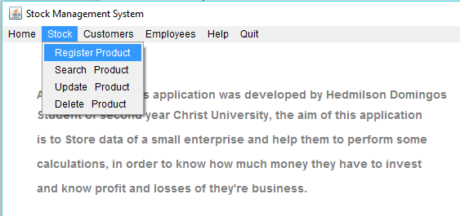
In the home page will find a menu on top with the following options:
- Home
- Stock
  - Register Product
  - Search Product
  - Update Product
  - Delete Product
- Customers
  - Register Customers
  - Edit Customer’s Information
  - Remove Customer
- Employees
  - Register Employees
  - Edit Employee’s Information
  - Remove Employee
- Help
- Quit

Register Product Frame

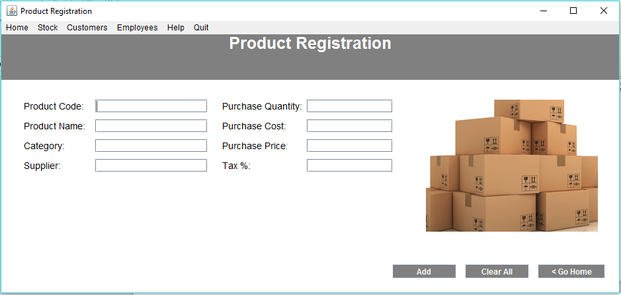
Code:
import java.io.*;
import java.awt.*;
import java.awt.event.*;
import javax.swing.*;
import javax.swing.JFrame;
import java.sql.*;
import java.sql.DriverManager;

public class registerCustomer extends WindowAdapter
{
Frame f6;
JButton bt1,bt2,bt3;
Label lb1,lb2,lb3,lb4,lb5,lb5_1,lb6,lb7,lb8,lb9,lb_img1,lb_id;
JPanel panel = new JPanel();
Font fn,fn2;
String gender;
JTextField t1,t2,t3,t4,t4_1,t4_2,t5,t6,t7,t8,t_gender,t_id;
Choice c;
JRadioButton r1=new JRadioButton("Male");
JRadioButton r2=new JRadioButton("Female");

public registerCustomer()
{
gui();
}
public void windowClosing(WindowEvent e)
{
f6.dispose();
mainFrame obj = new mainFrame();
}
public void gui()
{
f6 = new Frame("Customer Registration");
f6.addWindowListener(this);
f6.setBackground(Color.WHITE);

panel.setBackground(Color.GRAY);
panel.setBounds(5,40,950,100);

MenuBar mb = new MenuBar();
Menu menu = new Menu("Home");
Menu menu1 = new Menu("Stock");
// Menu submenu = new Menu("Sub Menu");
Menu menu2 = new Menu("Customers");
Menu submenu_custm = new Menu("Sub Menu");
Menu menu3 = new Menu("Employees");
Menu submenu_emp = new Menu("Sub Menu");
Menu menu4 = new Menu("Help");
Menu menu5 = new Menu("Quit");

//menu
MenuItem gohome = new MenuItem("Go Home");
menu.add(gohome);
//Quit
MenuItem quit = new MenuItem("Close Application");
menu5.add(quit);

// Items for the first menu1
MenuItem i1 = new MenuItem("Register Product");
MenuItem i2 = new MenuItem("Search Product");
MenuItem i3 = new MenuItem("Update Product");
MenuItem i4 = new MenuItem("Delete Product");
//MenuItem i5 = new MenuItem("Sub menu Item 2");

// Items for the Customers menu2
MenuItem i6 = new MenuItem("Register");
MenuItem i7 = new MenuItem("Edit");
MenuItem i8 = new MenuItem("View");

// Items for the Employess menu3
MenuItem i9 = new MenuItem("Register");
MenuItem i10 = new MenuItem("Edit");
MenuItem i11 = new MenuItem("View");

gohome.addActionListener(new ActionListener()
{
public void actionPerformed(ActionEvent e)
{
try
{
f6.dispose();
mainFrame regP = new mainFrame();
}
catch(Exception ex)
{
JOptionPane.showMessageDialog(null,ex);
}
}
});
quit.addActionListener(new ActionListener()
{
public void actionPerformed(ActionEvent e)
{
try
{
f6.dispose();
}
catch(Exception ex)
{
JOptionPane.showMessageDialog(null,ex);
}
}
});
i1.addActionListener(new ActionListener()
{
public void actionPerformed(ActionEvent e)
{
try
{
f6.dispose();
registerProduct regP = new registerProduct();
}
catch(Exception ex)
{
JOptionPane.showMessageDialog(null,ex);
}
}
});
i2.addActionListener(new ActionListener()
{
public void actionPerformed(ActionEvent e)
{
try
{
f6.dispose();
searchProduct regP = new searchProduct();
}
catch(Exception ex)
{
JOptionPane.showMessageDialog(null,ex);
}
}
});
i3.addActionListener(new ActionListener()
{
public void actionPerformed(ActionEvent e)
{
try
{
f6.dispose();
updateProduct regP = new updateProduct();
}
catch(Exception ex)
{
JOptionPane.showMessageDialog(null,ex);
}
}
});
i4.addActionListener(new ActionListener()
{
public void actionPerformed(ActionEvent e)
{
try
{
f6.dispose();
deleteProduct regP = new deleteProduct();
}
catch(Exception ex)
{
JOptionPane.showMessageDialog(null,ex);
}
}
});
fn = new Font("Arial",Font.BOLD,25);
lb1 = new Label("Customer Registration");
lb1.setForeground(Color.white);
lb1.setFont(fn);
lb1.setBounds(10,40,80,25);

fn2 = new Font("Arial",Font.PLAIN,14);
lb2 = new Label("First Name");
lb2.setFont(fn2);
lb2.setBounds(40,150,100,20);
lb2.setForeground(Color.BLACK);

lb3 = new Label("Last Name:");
lb3.setFont(fn2);
lb3.setBounds(40,180,100,20);
lb3.setForeground(Color.BLACK);

lb4 = new Label("Mobile no:");
lb4.setFont(fn2);
lb4.setBounds(40,210,100,20);
lb4.setForeground(Color.BLACK);

lb5 = new Label("DOB:");
lb5.setFont(fn2);
lb5.setBounds(40,240,100,20);
lb5.setForeground(Color.BLACK);

lb5_1 = new Label("Gender:");
lb5_1.setFont(fn2);
lb5_1.setBounds(40,270,100,20);
lb5_1.setForeground(Color.BLACK);

t1 = new JTextField("");
t1.setBounds(150,150,170,20);
t2 = new JTextField("");
t2.setBounds(150,180,170,20);
t3 = new JTextField("");
t3.setBounds(150,210,170,20);
t3.addKeyListener(new KeyAdapter()
{
public void keyTyped(KeyEvent e)
{
char character = e.getKeyChar();
if (((character < '0') || (character > '9')) && (character != '\b'))
{
e.consume();
}
else if (t3.getText().length() >= 10)
{
e.consume();
}
}
});
t4 = new JTextField("");
t4.setBounds(150,240,40,20);
t4_1 = new JTextField("");
t4_1.setBounds(200,240,40,20);
t4_2 = new JTextField("");
t4_2.setBounds(250,240,70,20);
t4.addKeyListener(new KeyAdapter()
{
public void keyTyped(KeyEvent e)
{
char character = e.getKeyChar();
if (((character < '0') || (character > '9')) && (character != '\b'))
{
e.consume();
}
else if (t4.getText().length() >= 2)
{
e.consume();
}
}
});
t4_1.addKeyListener(new KeyAdapter()
{
public void keyTyped(KeyEvent e)
{
char character = e.getKeyChar();
if (((character < '0') || (character > '9')) && (character != '\b'))
{
e.consume();
}
else if (t4_1.getText().length() >= 2)
{
e.consume();
}
}
});
t4_2.addKeyListener(new KeyAdapter()
{
public void keyTyped(KeyEvent e)
{
char character = e.getKeyChar();
if (((character < '0') || (character > '9')) && (character != '\b'))
{
e.consume();
}
else if (t4_2.getText().length() >= 4)
{
e.consume();
}
}
});

r1.setBounds(150,270,60,20);
r1.setForeground(Color.BLACK);
r1.setBackground(Color.WHITE);
r2.setBounds(220,270,70,20);
r2.setForeground(Color.BLACK);
r2.setBackground(Color.WHITE);

ButtonGroup bg = new ButtonGroup();
bg.add(r1);
bg.add(r2);
f6.add(r1);
f6.add(r2);

lb6 = new Label("Address:");
lb6.setFont(fn2);
lb6.setBounds(340,150,125,20);
lb6.setForeground(Color.BLACK);

lb7 = new Label("City:");
lb7.setFont(fn2);
lb7.setBounds(340,180,100,20);
lb7.setForeground(Color.BLACK);

lb8 = new Label("Postal Code:");
lb8.setFont(fn2);
lb8.setBounds(340,210,100,20);
lb8.setForeground(Color.BLACK);

lb9 = new Label("Country:");
lb9.setFont(fn2);
lb9.setBounds(340,240,100,20);
lb9.setForeground(Color.BLACK);

lb_id = new Label("Customer ID:");
lb_id.setFont(fn2);
lb_id.setBounds(340,270,100,20);
lb_id.setForeground(Color.BLACK);

t5 = new JTextField("");
t5.setBounds(470,150,130,20);
t6 = new JTextField("");
t6.setBounds(470,180,130,20);
t7 = new JTextField("");
t7.setBounds(470,210,130,20);
t7.addKeyListener(new KeyAdapter()
{
public void keyTyped(KeyEvent e)
{
char character = e.getKeyChar();
if (((character < '0') || (character > '9')) && (character != '\b'))
{
e.consume();
}
}
});
/*t8 = new JTextField("");
t8.setBounds(470,240,130,20);*/
c = new Choice();
c.setBounds(470,240,130,20);
c.add("Afganistan");
c.add("Angola");
c.add("Brasil");
c.add("India");
c.add("USA");

t_id = new JTextField("");
t_id.setBounds(470,270,130,20);
f6.add(c);

bt1 = new JButton("Register");
bt1.setBackground(Color.GRAY);
bt1.setForeground(Color.WHITE);
bt1.setBounds(600,400,95,20);

bt2 = new JButton("Clear All");
bt2.setBackground(Color.GRAY);
bt2.setForeground(Color.WHITE);
bt2.setBounds(710,400,95,20);

bt3 = new JButton("< Go Home");
bt3.setBackground(Color.GRAY);
bt3.setForeground(Color.WHITE);
bt3.setBounds(820,400,100,20);

JLabel lb_img1 = new JLabel(new ImageIcon("A:/IV_semester/Java_lab/CIA 3/imgs/solutions.png"));
//lb_img1.setLayout(null);
lb_img1.setBounds(650,150,260,200);
//lb_img1.setSize(650,400);
t_gender = new JTextField("");
bt1.addActionListener(new ActionListener()
{
public void actionPerformed(ActionEvent e2)
{
try
{
if (r1.isSelected())
{
t_gender.setText("Male");
}
else if (r2.isSelected())
{
t_gender.setText("Female");
}
theQuery("insert into customer (customer_id ,first_name, last_name, mobile_no, day, month, year, gender, address, city,postal_code,country) values ('"+t_id.getText()+"','"+t1.getText()+"','"+t2.getText()+"','"+t3.getText()+"','"+t4.getText()+"','"+t4_1.getText()+"','"+t4_2.getText()+"','"+t_gender.getText()+"','"+t5.getText()+"','"+t6.getText()+"','"+t7.getText()+"','"+c.getSelectedItem()+"') ");
JOptionPane.showMessageDialog(null," Data successfully saved...\n Thank you very much...");
}
catch(Exception ex)
{
JOptionPane.showMessageDialog(null,ex);
}
}
});

bt2.addActionListener(new ActionListener()
{
public void actionPerformed(ActionEvent e2)
{
try
{
t1.setText("");
t2.setText("");
t3.setText("");
t4.setText("");
t4_1.setText("");
t4_2.setText("");
t5.setText("");
t6.setText("");
t7.setText("");
t_id.setText("");
}
catch(Exception ex)
{
JOptionPane.showMessageDialog(null,ex);
}
}
});

bt3.addActionListener(new ActionListener()
{
public void actionPerformed(ActionEvent e3)
{
try
{
f6.dispose();
mainFrame obj1 = new mainFrame();
}
catch(Exception ex)
{
JOptionPane.showMessageDialog(null,ex);
}
}
});

menu1.add(i1);
menu1.add(i2);
menu1.add(i3);
menu1.add(i4);
menu2.add(i6);
menu2.add(i7);
menu2.add(i8);
menu3.add(i9);
menu3.add(i10);
menu3.add(i11);

mb.add(menu);
mb.add(menu1);
mb.add(menu2);
mb.add(menu3);
mb.add(menu4);
mb.add(menu5);
f6.setMenuBar(mb);
panel.add(lb1);
f6.add(panel);
f6.add(lb2);
f6.add(lb3);
f6.add(lb4);
f6.add(lb4);
f6.add(lb4);
f6.add(lb5);
f6.add(lb5_1);
f6.add(lb6);
f6.add(lb7);
f6.add(lb8);
f6.add(lb9);
f6.add(lb_id);

f6.add(t1);
f6.add(t2);
f6.add(t3);
f6.add(t4);
f6.add(t4_1);
f6.add(t4_2);
f6.add(t5);
f6.add(t6);
f6.add(t7);
f6.add(t_id);

f6.add(bt1);
f6.add(bt2);
f6.add(bt3);

f6.add(lb_img1);

f6.setLayout(null);
f6.setVisible(true);
f6.setSize(950,450);
}
// SETTING UP THE CONNECTION
public void theQuery(String query)
{
Connection con = null;
Statement st = null;
try
{
con = DriverManager.getConnection("jdbc:mysql://localhost/sonoo","root","heddyshost");
st = con.createStatement();
st.executeUpdate(query);
}
catch(Exception ex)
{
JOptionPane.showMessageDialog(null, ex.getMessage());
}
}
public static void main(String[] args)
{
new registerCustomer();
}
}
Product Will get Stored in Database.
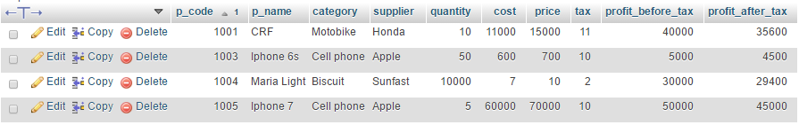
It will provide you the profit before and after tax rate.

Search Frame

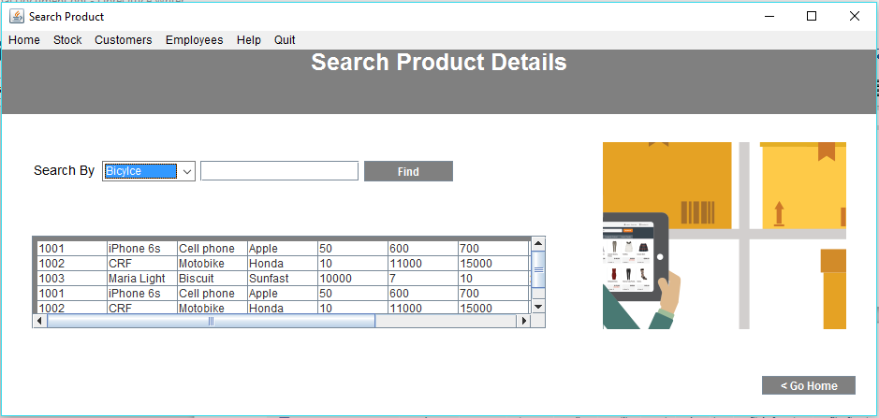
Code:
import java.io.*;
import java.awt.*;
import java.awt.event.*;
import javax.swing.*;
import javax.swing.event.*;
import javax.swing.JFrame;
import javax.swing.JPanel;
import javax.swing.JScrollPane;
import java.sql.*;
import java.sql.DriverManager;
import javax.swing.table.DefaultTableModel;

public class searchProduct extends WindowAdapter
{
Frame f3;
JButton bt1,bt2,bt3;
Label lb1,lb2,lb3,lb4,lb5,lb6,lb7,lb8,lb9,lb_img1;
JPanel panel,panel2;
Font fn,fn2;
Choice c;
JScrollPane scroll = new JScrollPane();

JTable jTable;

Connection con = null;
ResultSet rs = null;
PreparedStatement pst = null;

JTextField t1,t2,t3,t4,t5,t6,t7,t8;

public class ScrollTask implements ChangeListener
{
public void stateChanged(ChangeEvent e)
{
f3.revalidate();
f3.repaint();
}
}

String host = "jdbc:mysql://localhost/sonoo";
String username = "root";
String password = "heddyshost";
Statement st = null;

public searchProduct()
{
gui();
}
public void windowClosing(WindowEvent e)
{
f3.dispose();
mainFrame obj = new mainFrame();
}
public void gui()
{
f3 = new Frame("Search Product");
f3.addWindowListener(this);
f3.setBackground(Color.WHITE);

panel = new JPanel();
panel.setBackground(Color.GRAY);
panel.setBounds(5,40,950,80);

// Code for JTable
String[] columns = {"P. Code", "P. Name", "Category","Supplier","Quantity", "Cost", "Price","Tax","PBT","PAT"};
String[][] data = { {"1001","iPhone 6s", "Cell phone","Apple","50", "600","700","10","5000", "4500"},
{"1002","CRF", "Motobike","Honda","10", "11000","15000","11","40000", "35600"},
{"1003","Maria Light", "Biscuit","Sunfast","10000", "7","10","2","30000", "29400"},
{"1001","iPhone 6s", "Cell phone","Apple","50", "600","700","10","5000", "4500"},
{"1002","CRF", "Motobike","Honda","10", "11000","15000","11","40000", "35600"},
{"1003","Maria Light", "Biscuit","Sunfast","10000", "7","10","2","30000", "29400"}};
jTable = new JTable(data,columns);
jTable.setBounds(40,250,400,100);

panel2 = new JPanel();
panel2.setBackground(Color.GRAY);
panel2.setBounds(40,250,600,100);
panel2.add(jTable);
panel2.setLayout(new FlowLayout(FlowLayout.LEFT));
scroll.setVerticalScrollBarPolicy(JScrollPane.VERTICAL_SCROLLBAR_ALWAYS);
scroll.setHorizontalScrollBarPolicy(JScrollPane.HORIZONTAL_SCROLLBAR_ALWAYS);
scroll.setViewportView(panel2);
scroll.setPreferredSize(new Dimension(600,90));
scroll.setBounds(40,250,550,100);
f3.add(scroll);

MenuBar mb = new MenuBar();
Menu menu = new Menu("Home");
Menu menu1 = new Menu("Stock");
// Menu submenu = new Menu("Sub Menu");
Menu menu2 = new Menu("Customers");
Menu submenu_custm = new Menu("Sub Menu");
Menu menu3 = new Menu("Employees");
Menu submenu_emp = new Menu("Sub Menu");
Menu menu4 = new Menu("Help");
Menu menu5 = new Menu("Quit");

//menu
MenuItem gohome = new MenuItem("Go Home");
menu.add(gohome);

// Items for the first menu1
MenuItem i1 = new MenuItem("Register Product");
MenuItem i2 = new MenuItem("Search Product");
MenuItem i3 = new MenuItem("Update Product");
MenuItem i4 = new MenuItem("Delete Product");
//MenuItem i5 = new MenuItem("Sub menu Item 2");

// Items for the Customers menu2
MenuItem i6 = new MenuItem("Register");
MenuItem i7 = new MenuItem("Edit");
MenuItem i8 = new MenuItem("View");

// Items for the Employess menu3
MenuItem i9 = new MenuItem("Register");
MenuItem i10 = new MenuItem("Edit");
MenuItem i11 = new MenuItem("View");
//Quit
MenuItem quit = new MenuItem("Close Application");
menu5.add(quit);
quit.addActionListener(new ActionListener()
{
public void actionPerformed(ActionEvent e)
{
try
{
f3.dispose();
}
catch(Exception ex)
{
JOptionPane.showMessageDialog(null,ex);
}
}
});

gohome.addActionListener(new ActionListener()
{
public void actionPerformed(ActionEvent e)
{
try
{
f3.dispose();
mainFrame main = new mainFrame();
}
catch(Exception ex)
{
JOptionPane.showMessageDialog(null,ex);
}
}
});

i1.addActionListener(new ActionListener()
{
public void actionPerformed(ActionEvent e)
{
try
{
f3.dispose();
registerProduct regP = new registerProduct();
}
catch(Exception ex)
{
JOptionPane.showMessageDialog(null,ex);
}
}
});
i3.addActionListener(new ActionListener()
{
public void actionPerformed(ActionEvent e)
{
try
{
f3.dispose();
updateProduct regP = new updateProduct();
}
catch(Exception ex)
{
JOptionPane.showMessageDialog(null,ex);
}
}
});
i4.addActionListener(new ActionListener()
{
public void actionPerformed(ActionEvent e)
{
try
{
f3.dispose();
deleteProduct regP = new deleteProduct();
}
catch(Exception ex)
{
JOptionPane.showMessageDialog(null,ex);
}
}
});
i6.addActionListener(new ActionListener()
{
public void actionPerformed(ActionEvent e)
{
try
{
f3.dispose();
registerCustomer regP = new registerCustomer();
}
catch(Exception ex)
{
JOptionPane.showMessageDialog(null,ex);
}
}
});
fn = new Font("Arial",Font.BOLD,25);
lb1 = new Label("Search Product Details");
lb1.setForeground(Color.white);
lb1.setFont(fn);
lb1.setBounds(10,40,80,25);

fn2 = new Font("Arial",Font.PLAIN,14);
lb2 = new Label("Search By");
lb2.setFont(fn2);
lb2.setBounds(40,170,70,20);
lb2.setForeground(Color.black);

c = new Choice();
c.setBounds(115,170,100,20);
c.add("Bicylce");
c.add("Motobike");

t1 = new JTextField("");
t1.setBounds(220,170,170,22);

bt1 = new JButton("Find");
bt1.setBackground(Color.GRAY);
bt1.setForeground(Color.WHITE);
bt1.setBounds(395,170,95,22);

bt3 = new JButton("< Go Home");
bt3.setBackground(Color.GRAY);
bt3.setForeground(Color.WHITE);
bt3.setBounds(820,400,100,20);

JLabel lb_img1 = new JLabel(new ImageIcon("A:/IV_semester/Java_lab/CIA 3/imgs/management3.png"));
lb_img1.setBounds(650,150,260,200);

bt1.addActionListener(new ActionListener()
{
public void actionPerformed(ActionEvent e2)
{
try
{
JOptionPane.showMessageDialog(null,"Search option not available at the moment.\nSorry for the inconvenience.!");
}
catch(Exception ex)
{
JOptionPane.showMessageDialog(null,ex);
}
}
});
bt3.addActionListener(new ActionListener()
{
public void actionPerformed(ActionEvent e3)
{
try
{
f3.dispose();
mainFrame obj1 = new mainFrame();
}
catch(Exception ex)
{
JOptionPane.showMessageDialog(null,ex);
}
}
});

menu1.add(i1);
menu1.add(i2);
menu1.add(i3);
menu1.add(i4);

menu2.add(i6);
menu2.add(i7);
menu2.add(i8);
menu3.add(i9);
menu3.add(i10);
menu3.add(i11);
mb.add(menu);
mb.add(menu1);
mb.add(menu2);
mb.add(menu3);
mb.add(menu4);
mb.add(menu5);
f3.setMenuBar(mb);
panel.add(lb1);
f3.add(panel);
f3.add(lb2);

f3.add(t1);

f3.add(bt1);
f3.add(bt3);

f3.add(lb_img1);

f3.add(c);

f3.setLayout(null);
f3.setVisible(true);
f3.setSize(950,450);
}
public static void main(String[] args)
{
new searchProduct();
}
}
Update Frame

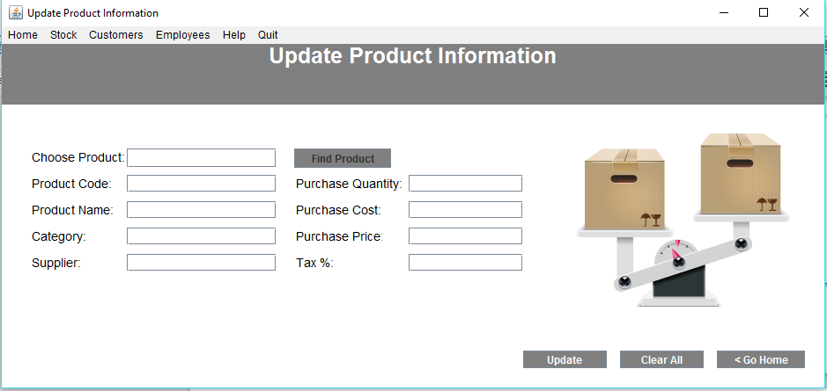
Code:
import java.io.*;
import java.awt.*;
import java.awt.event.*;
import javax.swing.*;
import javax.swing.JFrame;
import java.sql.*;
import java.sql.DriverManager;

class stock_update
{
Connection conn = null;
public static Connection ConnecrDb()
{
try
{
Class.forName("com.mysql.jdbc.Driver");
Connection conn = DriverManager.getConnection("jdbc:mysql://localhost/sonoo","root","heddyshost");
return conn;
}
catch(Exception e)
{
JOptionPane.showMessageDialog(null,e);
return null;
}
}
}

public class updateProduct extends WindowAdapter
{
Frame f4;
JButton bt1,bt2,bt3,bt_ser;
Label lb1,lb2,lb3,lb4,lb5,lb6,lb7,lb8,lb9,lb_img1,lb_ser;
//JLabel lb_img2;
JPanel panel = new JPanel();
Font fn,fn2;

JTextField t1,t2,t3,t4,t5,t6,t7,t8,t_ser;
JRadioButton r1=new JRadioButton("Male");
JRadioButton r2=new JRadioButton("Female");

Connection conn = null;
PreparedStatement pst = null;;
ResultSet rs = null;

int check = 0;

public updateProduct()
{
gui();
conn=stock_update.ConnecrDb();
}
public void windowClosing(WindowEvent e)
{
f4.dispose();
mainFrame obj = new mainFrame();
}
public void gui()
{
f4 = new Frame("Update Product Information");
f4.addWindowListener(this);
f4.setBackground(Color.WHITE);

panel.setBackground(Color.GRAY);
panel.setBounds(5,40,950,80);

MenuBar mb = new MenuBar();
Menu menu = new Menu("Home");
Menu menu1 = new Menu("Stock");
// Menu submenu = new Menu("Sub Menu");
Menu menu2 = new Menu("Customers");
Menu submenu_custm = new Menu("Sub Menu");
Menu menu3 = new Menu("Employees");
Menu submenu_emp = new Menu("Sub Menu");
Menu menu4 = new Menu("Help");
Menu menu5 = new Menu("Quit");

//menu
MenuItem gohome = new MenuItem("Go Home");
menu.add(gohome);

// Items for the first menu1
MenuItem i1 = new MenuItem("Register Product");
MenuItem i2 = new MenuItem("Search Product");
MenuItem i3 = new MenuItem("Update Product");
MenuItem i4 = new MenuItem("Delete Product");
//MenuItem i5 = new MenuItem("Sub menu Item 2");

// Items for the Customers menu2
MenuItem i6 = new MenuItem("Register");
MenuItem i7 = new MenuItem("Edit");
MenuItem i8 = new MenuItem("View");

// Items for the Employess menu3
MenuItem i9 = new MenuItem("Register");
MenuItem i10 = new MenuItem("Edit");
MenuItem i11 = new MenuItem("View");

//Quit
MenuItem quit = new MenuItem("Close Application");
menu5.add(quit);
quit.addActionListener(new ActionListener()
{
public void actionPerformed(ActionEvent e)
{
try
{
f4.dispose();
}
catch(Exception ex)
{
JOptionPane.showMessageDialog(null,ex);
}
}
});

gohome.addActionListener(new ActionListener()
{
public void actionPerformed(ActionEvent e)
{
try
{
f4.dispose();
mainFrame regP = new mainFrame();
}
catch(Exception ex)
{
JOptionPane.showMessageDialog(null,ex);
}
}
});

i1.addActionListener(new ActionListener()
{
public void actionPerformed(ActionEvent e)
{
try
{
f4.dispose();
registerProduct regP = new registerProduct();
}
catch(Exception ex)
{
JOptionPane.showMessageDialog(null,ex);
}
}
});
i2.addActionListener(new ActionListener()
{
public void actionPerformed(ActionEvent e)
{
try
{
f4.dispose();
searchProduct regP = new searchProduct();
}
catch(Exception ex)
{
JOptionPane.showMessageDialog(null,ex);
}
}
});
i4.addActionListener(new ActionListener()
{
public void actionPerformed(ActionEvent e)
{
try
{
f4.dispose();
deleteProduct regP = new deleteProduct();
}
catch(Exception ex)
{
JOptionPane.showMessageDialog(null,ex);
}
}
});
i6.addActionListener(new ActionListener()
{
public void actionPerformed(ActionEvent e)
{
try
{
f4.dispose();
registerCustomer regP = new registerCustomer();
}
catch(Exception ex)
{
JOptionPane.showMessageDialog(null,ex);
}
}
});
fn = new Font("Arial",Font.BOLD,25);
lb1 = new Label("Update Product Information");
lb1.setForeground(Color.WHITE);
lb1.setFont(fn);
lb1.setBounds(10,40,80,25);

fn2 = new Font("Arial",Font.PLAIN,14);
lb_ser = new Label("Choose Product:");
lb_ser.setFont(fn2);
lb_ser.setBounds(40,170,110,20);
lb_ser.setForeground(Color.BLACK);

t_ser = new JTextField("");
t_ser.setBounds(150,170,170,22);

bt_ser = new JButton("Find Product");
bt_ser.setBackground(Color.GRAY);
bt_ser.setBounds(340,170,110,22);

lb2 = new Label("Product Code:");
lb2.setFont(fn2);
lb2.setBounds(40,200,100,20);
lb2.setForeground(Color.BLACK);

lb3 = new Label("Product Name:");
lb3.setFont(fn2);
lb3.setBounds(40,230,100,20);
lb3.setForeground(Color.BLACK);

lb4 = new Label("Category:");
lb4.setFont(fn2);
lb4.setBounds(40,260,100,20);
lb4.setForeground(Color.BLACK);

lb5 = new Label("Supplier:");
lb5.setFont(fn2);
lb5.setBounds(40,290,100,20);
lb5.setForeground(Color.BLACK);

t1 = new JTextField("");
t1.setBounds(150,200,170,20);
t2 = new JTextField("");
t2.setBounds(150,230,170,20);
t3 = new JTextField("");
t3.setBounds(150,260,170,20);
t4 = new JTextField("");
t4.setBounds(150,290,170,20);

lb6 = new Label("Purchase Quantity:");
lb6.setFont(fn2);
lb6.setBounds(340,200,125,20);
lb6.setForeground(Color.BLACK);

lb7 = new Label("Purchase Cost:");
lb7.setFont(fn2);
lb7.setBounds(340,230,100,20);
lb7.setForeground(Color.BLACK);

lb8 = new Label("Purchase Price:");
lb8.setFont(fn2);
lb8.setBounds(340,260,100,20);
lb8.setForeground(Color.BLACK);

lb9 = new Label("Tax %:");
lb9.setFont(fn2);
lb9.setBounds(340,290,100,20);
lb9.setForeground(Color.BLACK);

t5 = new JTextField("");
t5.setBounds(470,200,130,20);
t6 = new JTextField("");
t6.setBounds(470,230,130,20);
t7 = new JTextField("");
t7.setBounds(470,260,130,20);
t8 = new JTextField("");
t8.setBounds(470,290,130,20);

t_ser.addKeyListener(new KeyAdapter()
{
public void keyTyped(KeyEvent e)
{
char character = e.getKeyChar();
if ((character < '0') || (character > '9'))
{
e.consume();
}
}
});
t1.addKeyListener(new KeyAdapter()
{
public void keyTyped(KeyEvent e)
{
char character = e.getKeyChar();
if ((character < '0') || (character > '9'))
{
e.consume();
}
}
});
t5.addKeyListener(new KeyAdapter()
{
public void keyTyped(KeyEvent e)
{
char character = e.getKeyChar();
if ((character < '0') || (character > '9'))
{
e.consume();
}
}
});
t6.addKeyListener(new KeyAdapter()
{
public void keyTyped(KeyEvent e)
{
char character = e.getKeyChar();
if ((character < '0') || (character > '9'))
{
e.consume();
}
}
});
t7.addKeyListener(new KeyAdapter()
{
public void keyTyped(KeyEvent e)
{
char character = e.getKeyChar();
if ((character < '0') || (character > '9'))
{
e.consume();
}
}
});
t8.addKeyListener(new KeyAdapter()
{
public void keyTyped(KeyEvent e)
{
char character = e.getKeyChar();
if ((character < '0') || (character > '9'))
{
e.consume();
}
}
});

bt1 = new JButton("Update");
bt1.setBackground(Color.GRAY);
bt1.setForeground(Color.WHITE);
bt1.setBounds(600,400,95,20);

bt2 = new JButton("Clear All");
bt2.setBackground(Color.GRAY);
bt2.setForeground(Color.WHITE);
bt2.setBounds(710,400,95,20);

bt3 = new JButton("< Go Home");
bt3.setBackground(Color.GRAY);
bt3.setForeground(Color.WHITE);
bt3.setBounds(820,400,100,20);

JLabel lb_img1 = new JLabel(new ImageIcon("A:/IV_semester/Java_lab/CIA 3/imgs/inventory-management.png"));
lb_img1.setBounds(650,150,260,200);
bt_ser.addActionListener(new ActionListener()
{
public void actionPerformed(ActionEvent e2)
{
try
{
String sql = "select p_code from product where p_code=?";
pst = conn.prepareStatement(sql);
pst.setString(1, t_ser.getText());
rs= pst.executeQuery();
if(rs.next())
{
pst = conn.prepareStatement("select p_code,p_name,category,supplier,quantity,cost,price,tax from product where p_code='"+t_ser.getText()+"'");
rs = pst.executeQuery();

while(rs.next())
{
t1.setText(rs.getString("p_code"));
t2.setText(rs.getString("p_name"));
t3.setText(rs.getString("category"));
t4.setText(rs.getString("supplier"));
t5.setText(rs.getString("quantity"));
t6.setText(rs.getString("cost"));
t7.setText(rs.getString("price"));
t8.setText(rs.getString("tax"));
check=1;
}
}
else
{
JOptionPane.showMessageDialog(null,"Product '"+t_ser.getText() +"' is not available in our database!");
}
}
catch(Exception e3)
{
JOptionPane.showMessageDialog(null, e3);
}
}
});

bt1.addActionListener(new ActionListener()
{
public void actionPerformed(ActionEvent e2)
{
Double cal_tax, product_cost, product_price, profit_before_tax, profit_after_tax, total_amount_to_spend, total_amount_to_Gain;
int tax,quantity,code;
if (check==1)
{
try
{
product_cost = Double.parseDouble(t6.getText());
quantity = Integer.parseInt(t5.getText());
product_price = Double.parseDouble(t7.getText());
tax = Integer.parseInt(t8.getText());

total_amount_to_spend = product_cost * quantity;
total_amount_to_Gain = product_price * quantity;

profit_before_tax = total_amount_to_Gain - total_amount_to_spend;

cal_tax = (profit_before_tax*tax)/100;

profit_after_tax = profit_before_tax - cal_tax;
theQuery("update product set p_code = '"+t1.getText()+"', p_name = '"+t2.getText()+"', category = '"+t3.getText()+"',supplier = '"+t4.getText()+"', quantity = '"+t5.getText()+"', cost = '"+t6.getText()+"', price = '"+t7.getText()+"', tax = '"+t8.getText()+"', profit_before_tax='"+profit_before_tax+"', profit_after_tax='"+profit_after_tax+"' where p_code='"+t_ser.getText()+"' ");
JOptionPane.showMessageDialog(null,"Product Information got updated successfully!\n\nThank you.");
check=0;
}
catch(Exception ex)
{
JOptionPane.showMessageDialog(null,ex);
}
}
else
{
JOptionPane.showMessageDialog(null,"You need to reteive the Information\nby clicking in the button 'Find Product'.\nThank you. ");
}
}
});
bt2.addActionListener(new ActionListener()
{
public void actionPerformed(ActionEvent e2)
{
try
{
t_ser.setText("");
t1.setText("");
t2.setText("");
t3.setText("");
t4.setText("");

t5.setText("");
t6.setText("");
t7.setText("");
t8.setText("");
}
catch(Exception ex)
{
JOptionPane.showMessageDialog(null,ex);
}
}
});

bt3.addActionListener(new ActionListener()
{
public void actionPerformed(ActionEvent e3)
{
try
{
f4.dispose();
mainFrame obj1 = new mainFrame();
}
catch(Exception ex)
{
JOptionPane.showMessageDialog(null,ex);
}
}
});

menu1.add(i1);
menu1.add(i2);
menu1.add(i3);
menu1.add(i4);
menu2.add(i6);
menu2.add(i7);
menu2.add(i8);
menu3.add(i9);
menu3.add(i10);
menu3.add(i11);

mb.add(menu);
mb.add(menu1);
mb.add(menu2);
mb.add(menu3);
mb.add(menu4);
mb.add(menu5);

f4.setMenuBar(mb);
panel.add(lb1);
f4.add(panel);

f4.add(lb2);
f4.add(lb3);
f4.add(lb4);
f4.add(lb5);
f4.add(lb6);
f4.add(lb7);
f4.add(lb8);
f4.add(lb9);

f4.add(t1);
f4.add(t2);
f4.add(t3);
f4.add(t4);
f4.add(t5);
f4.add(t6);
f4.add(t7);
f4.add(t8);

f4.add(bt1);
f4.add(bt2);
f4.add(bt3);

f4.add(lb_img1);

f4.add(lb_ser);
f4.add(t_ser);
f4.add(bt_ser);

f4.setLayout(null);
f4.setVisible(true);
f4.setSize(950,450);
}
// SETTING UP THE CONNECTION
public void theQuery(String query)
{
Connection con = null;
Statement st = null;
try
{
con = DriverManager.getConnection("jdbc:mysql://localhost/sonoo","root","heddyshost");
st = con.createStatement();
st.executeUpdate(query);
}
catch(Exception ex)
{
JOptionPane.showMessageDialog(null, ex.getMessage());
}
}
public static void main(String[] args)
{
new updateProduct();
}
}
Deletion Frame

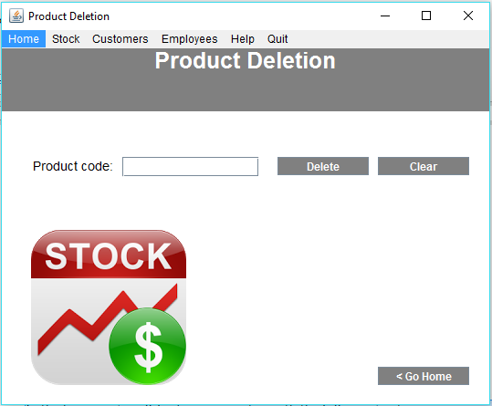
Code:
import java.io.*;
import java.awt.*;
import java.awt.event.*;
import javax.swing.*;
import javax.swing.JFrame;
import java.sql.*;
import java.sql.DriverManager;

class connection_class
{
Connection con = null;
public static Connection ConnecrDb()
{
try
{
Class.forName("com.mysql.jdbc.Driver");
Connection con = DriverManager.getConnection("jdbc:mysql://localhost/sonoo","root","heddyshost");
return con;
}
catch(Exception e)
{
JOptionPane.showMessageDialog(null,e);
return null;
}
}
}
public class deleteProduct extends WindowAdapter
{
Connection con = null;
ResultSet rs = null;
PreparedStatement pst = null;

Frame f5;
JButton bt1,bt2,bt3;
Label lb1,lb2,lb3,lb4,lb5,lb6,lb7,lb8,lb9,lb_img1;
JPanel panel = new JPanel();
Font fn,fn2;
Choice c;

JTextField t1;

public deleteProduct()
{
gui();
con = connection_class.ConnecrDb();
}
public void windowClosing(WindowEvent e)
{
f5.dispose();
mainFrame obj = new mainFrame();
}
public void gui()
{
f5 = new Frame("Product Deletion");
f5.addWindowListener(this);
f5.setBackground(Color.WHITE);

panel.setBackground(Color.GRAY);
panel.setBounds(5,40,550,80);

MenuBar mb = new MenuBar();
Menu menu = new Menu("Home");
Menu menu1 = new Menu("Stock");
// Menu submenu = new Menu("Sub Menu");
Menu menu2 = new Menu("Customers");
Menu submenu_custm = new Menu("Sub Menu");
Menu menu3 = new Menu("Employees");
Menu submenu_emp = new Menu("Sub Menu");
Menu menu4 = new Menu("Help");
Menu menu5 = new Menu("Quit");

//Manu
MenuItem gohome = new MenuItem("Go Home");

// Items for the first menu1
MenuItem i1 = new MenuItem("Register Product");
MenuItem i2 = new MenuItem("Search Product");
MenuItem i3 = new MenuItem("Update Product");
MenuItem i4 = new MenuItem("Delete Product");
//MenuItem i5 = new MenuItem("Sub menu Item 2");

// Items for the Customers menu2
MenuItem i6 = new MenuItem("Register");
MenuItem i7 = new MenuItem("Edit");
MenuItem i8 = new MenuItem("View");

// Items for the Employess menu3
MenuItem i9 = new MenuItem("Register");
MenuItem i10 = new MenuItem("Edit");
MenuItem i11 = new MenuItem("View");

//Quit
MenuItem quit = new MenuItem("Close Application");
menu5.add(quit);
quit.addActionListener(new ActionListener()
{
public void actionPerformed(ActionEvent e)
{
try
{
f5.dispose();
}
catch(Exception ex)
{
JOptionPane.showMessageDialog(null,ex);
}
}
});

gohome.addActionListener(new ActionListener()
{
public void actionPerformed(ActionEvent e)
{
try
{
f5.dispose();
mainFrame main = new mainFrame();
}
catch(Exception ex)
{
JOptionPane.showMessageDialog(null,ex);
}
}
});

i1.addActionListener(new ActionListener()
{
public void actionPerformed(ActionEvent e)
{
try
{
f5.dispose();
registerProduct regP = new registerProduct();
}
catch(Exception ex)
{
JOptionPane.showMessageDialog(null,ex);
}
}
});
i2.addActionListener(new ActionListener()
{
public void actionPerformed(ActionEvent e)
{
try
{
f5.dispose();
searchProduct regP = new searchProduct();
}
catch(Exception ex)
{
JOptionPane.showMessageDialog(null,ex);
}
}
});
i3.addActionListener(new ActionListener()
{
public void actionPerformed(ActionEvent e)
{
try
{
f5.dispose();
updateProduct regP = new updateProduct();
}
catch(Exception ex)
{
JOptionPane.showMessageDialog(null,ex);
}
}
});
fn = new Font("Arial",Font.BOLD,25);
lb1 = new Label("Product Deletion");
lb1.setForeground(Color.white);
lb1.setFont(fn);
lb1.setBounds(10,40,80,25);

fn2 = new Font("Arial",Font.PLAIN,14);
lb2 = new Label("Product code:");
lb2.setFont(fn2);
lb2.setBounds(40,170,90,20);
lb2.setForeground(Color.BLACK);

t1 = new JTextField("");
t1.setBounds(140,170,150,22);
t1.addKeyListener(new KeyAdapter()
{
public void keyTyped(KeyEvent e)
{
char character = e.getKeyChar();
if (((character < '0') || (character > '9')) && (character != '\b'))
{
e.consume();
}
}
});

/*lb3 = new Label("Product Name:");
lb3.setFont(fn2);
lb3.setBounds(40,180,100,20);
lb3.setForeground(Color.white);

t1 = new JTextField("");
t1.setBounds(150,150,170,20); */

bt1 = new JButton("Delete");
bt1.setBackground(Color.GRAY);
bt1.setForeground(Color.WHITE);
bt1.setBounds(310,170,100,20);

bt2 = new JButton("Clear");
bt2.setBackground(Color.GRAY);
bt2.setForeground(Color.WHITE);
bt2.setBounds(420,170,100,20);

bt3 = new JButton("< Go Home");
bt3.setBackground(Color.GRAY);
bt3.setForeground(Color.WHITE);
bt3.setBounds(420,400,100,20);

JLabel lb_img1 = new JLabel(new ImageIcon("A:/IV_semester/Java_lab/CIA 3/imgs/stock3.png"));
//lb_img1.setLayout(null);
lb_img1.setBounds(-25,210,300,250);
//lb_img1.setSize(650,400);

bt1.addActionListener(new ActionListener()
{
public void actionPerformed(ActionEvent e2)
{
try
{
String sql="select p_code from product where p_code=?";
pst = con.prepareStatement(sql);
pst.setString(1, t1.getText());
rs= pst.executeQuery();
if(rs.next())
{
JOptionPane.showMessageDialog(null,"Product '"+t1.getText()+"' is available!\n\nClick ok then it will get deleted.");
theQuery("delete from product where p_code='"+t1.getText()+"'");
JOptionPane.showMessageDialog(null,"Product '"+ t1.getText() +"' was successfully deleted.");
}
else
{
JOptionPane.showMessageDialog(null,"Product '"+t1.getText()+"' is not available in our database!");
}
}
catch(Exception ex)
{
JOptionPane.showMessageDialog(null,ex);
}
}
});
bt2 .addActionListener(new ActionListener()
{
public void actionPerformed(ActionEvent e3)
{
try
{
t1.setText("");
}
catch(Exception ex)
{
JOptionPane.showMessageDialog(null,ex);
}
}
});
bt3.addActionListener(new ActionListener()
{
public void actionPerformed(ActionEvent e3)
{
try
{
f5.dispose();
mainFrame obj1 = new mainFrame();
}
catch(Exception ex)
{
JOptionPane.showMessageDialog(null,ex);
}
}
});
i6.addActionListener(new ActionListener()
{
public void actionPerformed(ActionEvent e)
{
try
{
f5.dispose();
registerCustomer regP = new registerCustomer();
}
catch(Exception ex)
{
JOptionPane.showMessageDialog(null,ex);
}
}
});

menu.add(gohome);

menu1.add(i1);
menu1.add(i2);
menu1.add(i3);
menu1.add(i4);

menu2.add(i6);
menu2.add(i7);
menu2.add(i8);

menu3.add(i9);
menu3.add(i10);
menu3.add(i11);

mb.add(menu);
mb.add(menu1);
mb.add(menu2);
mb.add(menu3);
mb.add(menu4);
mb.add(menu5);

f5.setMenuBar(mb);
panel.add(lb1);
f5.add(panel);

f5.add(lb2);

f5.add(t1);

f5.add(bt1);
f5.add(bt2);
f5.add(bt3);

f5.add(lb_img1);

f5.setLayout(null);
f5.setVisible(true);
f5.setSize(550,450);
}
// SETTING UP THE CONNECTION
public void theQuery(String query)
{
Connection con = null;
Statement st = null;
try
{
con = DriverManager.getConnection("jdbc:mysql://localhost/sonoo","root","heddyshost");
st = con.createStatement();
st.executeUpdate(query);
JOptionPane.showMessageDialog(null, "Query executed");
}
catch(Exception ex)
{
JOptionPane.showMessageDialog(null, ex.getMessage());
}
}
public static void main(String[] args)
{
new deleteProduct();
}
}
Menu Bar

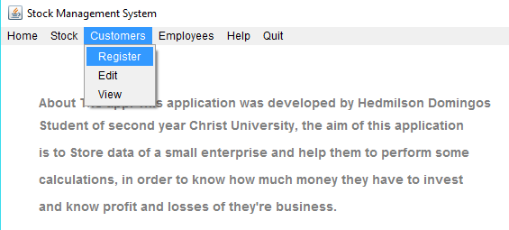
It will possible to register customers and employees as well, Edit and visualize their information.
- Register customers and employees as well.
- Edit and visualize their information.
Features:
It will be possible to Track the product that our customers buy.
- And much more.

Register Customer Frame

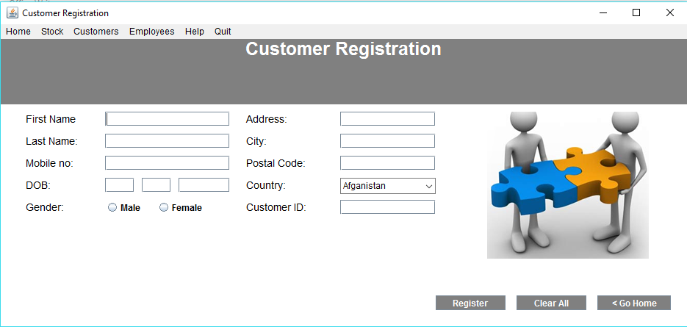

Code:
import java.io.*;
import java.awt.*;
import java.awt.event.*;
import javax.swing.*;
import javax.swing.JFrame;
import java.sql.*;
import java.sql.DriverManager;

public class registerCustomer extends WindowAdapter
{
Frame f6;
JButton bt1,bt2,bt3;
Label lb1,lb2,lb3,lb4,lb5,lb5_1,lb6,lb7,lb8,lb9,lb_img1,lb_id;
JPanel panel = new JPanel();
Font fn,fn2;
String gender;
JTextField t1,t2,t3,t4,t4_1,t4_2,t5,t6,t7,t8,t_gender,t_id;
Choice c;
JRadioButton r1=new JRadioButton("Male");
JRadioButton r2=new JRadioButton("Female");

public registerCustomer()
{
gui();
}
public void windowClosing(WindowEvent e)
{
f6.dispose();
mainFrame obj = new mainFrame();
}
public void gui()
{
f6 = new Frame("Customer Registration");
f6.addWindowListener(this);
f6.setBackground(Color.WHITE);

panel.setBackground(Color.GRAY);
panel.setBounds(5,40,950,100);

MenuBar mb = new MenuBar();
Menu menu = new Menu("Home");
Menu menu1 = new Menu("Stock");
// Menu submenu = new Menu("Sub Menu");
Menu menu2 = new Menu("Customers");
Menu submenu_custm = new Menu("Sub Menu");
Menu menu3 = new Menu("Employees");
Menu submenu_emp = new Menu("Sub Menu");
Menu menu4 = new Menu("Help");
Menu menu5 = new Menu("Quit");

//menu
MenuItem gohome = new MenuItem("Go Home");
menu.add(gohome);
//Quit
MenuItem quit = new MenuItem("Close Application");
menu5.add(quit);

// Items for the first menu1
MenuItem i1 = new MenuItem("Register Product");
MenuItem i2 = new MenuItem("Search Product");
MenuItem i3 = new MenuItem("Update Product");
MenuItem i4 = new MenuItem("Delete Product");
//MenuItem i5 = new MenuItem("Sub menu Item 2");

// Items for the Customers menu2
MenuItem i6 = new MenuItem("Register");
MenuItem i7 = new MenuItem("Edit");
MenuItem i8 = new MenuItem("View");

// Items for the Employess menu3
MenuItem i9 = new MenuItem("Register");
MenuItem i10 = new MenuItem("Edit");
MenuItem i11 = new MenuItem("View");

gohome.addActionListener(new ActionListener()
{
public void actionPerformed(ActionEvent e)
{
try
{
f6.dispose();
mainFrame regP = new mainFrame();
}
catch(Exception ex)
{
JOptionPane.showMessageDialog(null,ex);
}
}
});
quit.addActionListener(new ActionListener()
{
public void actionPerformed(ActionEvent e)
{
try
{
f6.dispose();
}
catch(Exception ex)
{
JOptionPane.showMessageDialog(null,ex);
}
}
});
i1.addActionListener(new ActionListener()
{
public void actionPerformed(ActionEvent e)
{
try
{
f6.dispose();
registerProduct regP = new registerProduct();
}
catch(Exception ex)
{
JOptionPane.showMessageDialog(null,ex);
}
}
});
i2.addActionListener(new ActionListener()
{
public void actionPerformed(ActionEvent e)
{
try
{
f6.dispose();
searchProduct regP = new searchProduct();
}
catch(Exception ex)
{
JOptionPane.showMessageDialog(null,ex);
}
}
});
i3.addActionListener(new ActionListener()
{
public void actionPerformed(ActionEvent e)
{
try
{
f6.dispose();
updateProduct regP = new updateProduct();
}
catch(Exception ex)
{
JOptionPane.showMessageDialog(null,ex);
}
}
});
i4.addActionListener(new ActionListener()
{
public void actionPerformed(ActionEvent e)
{
try
{
f6.dispose();
deleteProduct regP = new deleteProduct();
}
catch(Exception ex)
{
JOptionPane.showMessageDialog(null,ex);
}
}
});
fn = new Font("Arial",Font.BOLD,25);
lb1 = new Label("Customer Registration");
lb1.setForeground(Color.white);
lb1.setFont(fn);
lb1.setBounds(10,40,80,25);

fn2 = new Font("Arial",Font.PLAIN,14);
lb2 = new Label("First Name");
lb2.setFont(fn2);
lb2.setBounds(40,150,100,20);
lb2.setForeground(Color.BLACK);

lb3 = new Label("Last Name:");
lb3.setFont(fn2);
lb3.setBounds(40,180,100,20);
lb3.setForeground(Color.BLACK);

lb4 = new Label("Mobile no:");
lb4.setFont(fn2);
lb4.setBounds(40,210,100,20);
lb4.setForeground(Color.BLACK);

lb5 = new Label("DOB:");
lb5.setFont(fn2);
lb5.setBounds(40,240,100,20);
lb5.setForeground(Color.BLACK);

lb5_1 = new Label("Gender:");
lb5_1.setFont(fn2);
lb5_1.setBounds(40,270,100,20);
lb5_1.setForeground(Color.BLACK);

t1 = new JTextField("");
t1.setBounds(150,150,170,20);
t2 = new JTextField("");
t2.setBounds(150,180,170,20);
t3 = new JTextField("");
t3.setBounds(150,210,170,20);
t3.addKeyListener(new KeyAdapter()
{
public void keyTyped(KeyEvent e)
{
char character = e.getKeyChar();
if (((character < '0') || (character > '9')) && (character != '\b'))
{
e.consume();
}
else if (t3.getText().length() >= 10)
{
e.consume();
}
}
});
t4 = new JTextField("");
t4.setBounds(150,240,40,20);
t4_1 = new JTextField("");
t4_1.setBounds(200,240,40,20);
t4_2 = new JTextField("");
t4_2.setBounds(250,240,70,20);
t4.addKeyListener(new KeyAdapter()
{
public void keyTyped(KeyEvent e)
{
char character = e.getKeyChar();
if (((character < '0') || (character > '9')) && (character != '\b'))
{
e.consume();
}
else if (t4.getText().length() >= 2)
{
e.consume();
}
}
});
t4_1.addKeyListener(new KeyAdapter()
{
public void keyTyped(KeyEvent e)
{
char character = e.getKeyChar();
if (((character < '0') || (character > '9')) && (character != '\b'))
{
e.consume();
}
else if (t4_1.getText().length() >= 2)
{
e.consume();
}
}
});
t4_2.addKeyListener(new KeyAdapter()
{
public void keyTyped(KeyEvent e)
{
char character = e.getKeyChar();
if (((character < '0') || (character > '9')) && (character != '\b'))
{
e.consume();
}
else if (t4_2.getText().length() >= 4)
{
e.consume();
}
}
});

r1.setBounds(150,270,60,20);
r1.setForeground(Color.BLACK);
r1.setBackground(Color.WHITE);
r2.setBounds(220,270,70,20);
r2.setForeground(Color.BLACK);
r2.setBackground(Color.WHITE);

ButtonGroup bg = new ButtonGroup();
bg.add(r1);
bg.add(r2);
f6.add(r1);
f6.add(r2);

lb6 = new Label("Address:");
lb6.setFont(fn2);
lb6.setBounds(340,150,125,20);
lb6.setForeground(Color.BLACK);

lb7 = new Label("City:");
lb7.setFont(fn2);
lb7.setBounds(340,180,100,20);
lb7.setForeground(Color.BLACK);

lb8 = new Label("Postal Code:");
lb8.setFont(fn2);
lb8.setBounds(340,210,100,20);
lb8.setForeground(Color.BLACK);

lb9 = new Label("Country:");
lb9.setFont(fn2);
lb9.setBounds(340,240,100,20);
lb9.setForeground(Color.BLACK);

lb_id = new Label("Customer ID:");
lb_id.setFont(fn2);
lb_id.setBounds(340,270,100,20);
lb_id.setForeground(Color.BLACK);

t5 = new JTextField("");
t5.setBounds(470,150,130,20);
t6 = new JTextField("");
t6.setBounds(470,180,130,20);
t7 = new JTextField("");
t7.setBounds(470,210,130,20);
t7.addKeyListener(new KeyAdapter()
{
public void keyTyped(KeyEvent e)
{
char character = e.getKeyChar();
if (((character < '0') || (character > '9')) && (character != '\b'))
{
e.consume();
}
}
});
c = new Choice();
c.setBounds(470,240,130,20);
c.add("Afganistan");
c.add("Angola");
c.add("Brasil");
c.add("India");
c.add("USA");

t_id = new JTextField("");
t_id.setBounds(470,270,130,20);
f6.add(c);

bt1 = new JButton("Register");
bt1.setBackground(Color.GRAY);
bt1.setForeground(Color.WHITE);
bt1.setBounds(600,400,95,20);

bt2 = new JButton("Clear All");
bt2.setBackground(Color.GRAY);
bt2.setForeground(Color.WHITE);
bt2.setBounds(710,400,95,20);

bt3 = new JButton("< Go Home");
bt3.setBackground(Color.GRAY);
bt3.setForeground(Color.WHITE);
bt3.setBounds(820,400,100,20);

JLabel lb_img1 = new JLabel(new ImageIcon("A:/IV_semester/Java_lab/CIA 3/imgs/solutions.png"));
//lb_img1.setLayout(null);
lb_img1.setBounds(650,150,260,200);
//lb_img1.setSize(650,400);
t_gender = new JTextField("");
bt1.addActionListener(new ActionListener()
{
public void actionPerformed(ActionEvent e2)
{
try
{
if (r1.isSelected())
{
t_gender.setText("Male");
}
else if (r2.isSelected())
{
t_gender.setText("Female");
}
theQuery("insert into customer (customer_id ,first_name, last_name, mobile_no, day, month, year, gender, address, city,postal_code,country) values ('"+t_id.getText()+"','"+t1.getText()+"','"+t2.getText()+"','"+t3.getText()+"','"+t4.getText()+"','"+t4_1.getText()+"','"+t4_2.getText()+"','"+t_gender.getText()+"','"+t5.getText()+"','"+t6.getText()+"','"+t7.getText()+"','"+c.getSelectedItem()+"') ");
JOptionPane.showMessageDialog(null," Data successfully saved...\n Thank you very much...");
}
catch(Exception ex)
{
JOptionPane.showMessageDialog(null,ex);
}
}
});

bt2.addActionListener(new ActionListener()
{
public void actionPerformed(ActionEvent e2)
{
try
{
t1.setText("");
t2.setText("");
t3.setText("");
t4.setText("");
t4_1.setText("");
t4_2.setText("");
t5.setText("");
t6.setText("");
t7.setText("");
t_id.setText("");
}
catch(Exception ex)
{
JOptionPane.showMessageDialog(null,ex);
}
}
});

bt3.addActionListener(new ActionListener()
{
public void actionPerformed(ActionEvent e3)
{
try
{
f6.dispose();
mainFrame obj1 = new mainFrame();
}
catch(Exception ex)
{
JOptionPane.showMessageDialog(null,ex);
}
}
});

menu1.add(i1);
menu1.add(i2);
menu1.add(i3);
menu1.add(i4);

menu2.add(i6);
menu2.add(i7);
menu2.add(i8);

menu3.add(i9);
menu3.add(i10);
menu3.add(i11);

mb.add(menu);
mb.add(menu1);
mb.add(menu2);
mb.add(menu3);
mb.add(menu4);
mb.add(menu5);

f6.setMenuBar(mb);
panel.add(lb1);
f6.add(panel);

f6.add(lb2);
f6.add(lb3);
f6.add(lb4);
f6.add(lb4);
f6.add(lb4);
f6.add(lb5);
f6.add(lb5_1);
f6.add(lb6);
f6.add(lb7);
f6.add(lb8);
f6.add(lb9);
f6.add(lb_id);

f6.add(t1);
f6.add(t2);
f6.add(t3);
f6.add(t4);
f6.add(t4_1);
f6.add(t4_2);
f6.add(t5);
f6.add(t6);
f6.add(t7);
f6.add(t_id);

f6.add(bt1);
f6.add(bt2);
f6.add(bt3);

f6.add(lb_img1);

f6.setLayout(null);
f6.setVisible(true);
f6.setSize(950,450);
}
// SETTING UP THE CONNECTION
public void theQuery(String query)
{
Connection con = null;
Statement st = null;
try
{
con = DriverManager.getConnection("jdbc:mysql://localhost/sonoo","root","heddyshost");
st = con.createStatement();
st.executeUpdate(query);
}
catch(Exception ex)
{
JOptionPane.showMessageDialog(null, ex.getMessage());
}
}
public static void main(String[] args)
{
new registerCustomer();
}
}

